CF SNS ASSIGNMENT

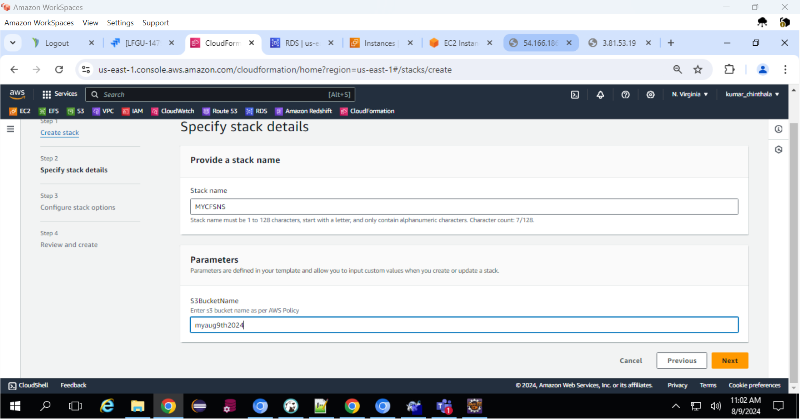

Created SNS Topic

Received Mail Notifications

